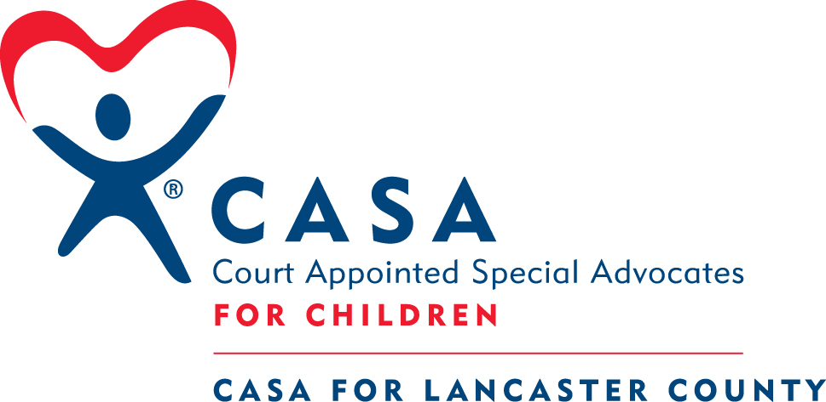
CASA for Lancaster County
1141 H Street, Suite C
Lincoln, NE 68508
402 474.5161
402 474.5188 (fax)

New Volunteer Training – Flexible Training
September/October 2015
Schedule subject to change – but probably won’t!
All training sessions will be held at
CASA for Lancaster County
1141 H Street, Suite C, 3rd Floor
Parking behind the building (south); please use west door,
Take the stairs to 3rd floor.
Trainers: Dawn Rockey, Alex Labenz, Krystal Rash, Kristi Morrow

We will meet once a week for 5 weeks on Tuesday evenings from 6:00PM to 9:00PM in addition to the shorter orientation session on Tuesday, September 22, 2015.

Sept. 22 Tuesday - Orientation 6:00 – 8:00 PM

Sept. 29 Tuesday – Session I 6:00 - 9:00 PM

Oct. 6 Tuesday – Session II 6:00-9:00 PM

Oct. 13 Tuesday – Session III 6:00-9:00 PM

Oct. 20 Tuesday – Session IV 6:00-9:00 PM

Oct. 27 Tuesday – Session V 6:00-9:00 PM

Swearing-in: October 28, 29, 30 - TBD

